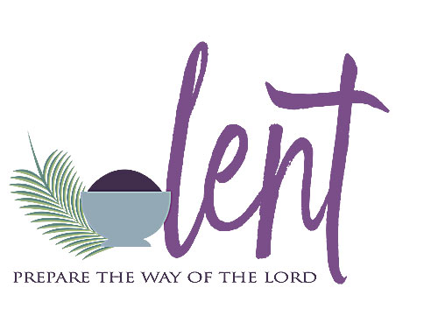
LENT PLAYLIST
The season of Lent invites us to take a close look at our lives, turn our minds and hearts back to God and intentionally prepare to renew our baptismal promises at Easter. There are a myriad of Lent resources for parishes and schools. As you prepare to guide your faith community through Lent, take a peek at some of the tools available at the 'click' of your mouse!
- Joe Paprocki's Catechist’s Journey arrives daily via email with suggestions for Catholic school teachers and parish catechists alike including a curation of Lent resources. Click here.
- Loyola Press has compiled excellent Lent Resources worth exploring. Click here.
- A great starter article is Lenten Activities for Children. Click here.
- Dynamic Catholic produces a daily video reflection. Sign up now for the Best Lent Ever 2021.
- The Liturgical Catechist curates a wide variety of Lent resources. Click here.
- The Religion Teacher also has great Lent activities. Click here.
- Sadlier Religion offers numerous links, articles and ideas. Click here.
- Busted Halo is a great website especially for those who work with teens and young adults. Take a look at 25 Great Things You Can Do for Lent & Lent In Three Minutes.
- Two short articles to inspire Lenten Practices are: Forty Lenten Ideas by Janet Schaeffler, OP and 101 Practical Fasting Ideas for Lent by Deacon Nick Senger.
- The McGrath Institute for Church Life offers a beautiful free, e-book called, A Spiritual Pilgrimage to Christ Through Lent: A Guide for Bible Study and Faith Sharing.
- The United States Catholic Conference of Bishops offers a Lent Calendar. Click here.
- The Catholic Apostolate Center compiles resources for Lent and Easter Calendar. Click here.
- Building Faith offers beautiful articles and ideas. Click here.
- The ideas on Pinterest are endless. Click here.
- The Pastoral Center has excellent resources to help coach and equip parents to introduce Jesus to their children. Growing Up Catholic - Home
Craft and Create:
https://mail.google.com/mail/u/0/?ogbl#inbox/FMfcgxwKkbrQKfNRgFZVdHBGkwKdPgCQ
https://mail.google.com/mail/u/0/?ogbl#inbox/FMfcgxwLsJrrnjXJXjgnHxxVcTRfhsWW
Stations of the Cross for Children
https://www.youtube.com/watch?v=j0qv7c4PsrA

